__________________________________________________

Usability Test

## **__________________________________________________**



**Project:**

A World of Things

**Client:**

Julian Hambleton-Jones

**Team:**

Funge

**Team Members:**

14214742 – Matthew Botha

14446619 – Gian Paolo Buffo

14027021 – Matthias Harvey

14035538 – Dillon Heins

## Pre-test Planning

The user base for the usability test consisted of two 3rd year university students and six working adults. These users were chosen because they represent the target population of the application - that is, people who may find interest in working with plants or could be influenced to enjoy working with plants. The users were requested either in person or via *Whatsapp* communication to attend the usability test and given a brief overview of what would be required of them.

The decisions of which tasks to create for the users were made by simulating the general workflow that a user of the system would follow. We wanted our user tasks to test the simplicity, ease-of-use, speed and functionality of our application, and thus designed the tasks around these criteria. We also provided the users with a “bonus task,” where they were given the opportunity to create their own task to test out something they would like to know more about.

We planned to interact with the users in a professional, yet friendly and approachable manner. That way, users felt that their contributions helped to shape an actual product, but at the same time they were relaxed enough to give us their honest opinions and execute the tasks in a stress-free environment.

## Process Followed

Before the users entered the usability labs, we set up the workspace as follows:

· Placed the informed consent form on the main table where users would wait until they were tested

· Set up the incentives (sweets) for the users on the main table

· Placed User Task sheets at each of the locations where the users would be seated to perform their tests

Once we had set up, we informed the users that they could enter the labs and take a seat at the main table. In the form of a speech, we introduced ourselves and the application that would be tested. We ensured that the users were aware of their ethical rights, what would be expected of them, and how their data would be used by us. We concluded the speech by asking if they had any further questions, and if not, they were welcome to sign the informed consent form and take a sweet as a way of showing our thanks.

Each of the four members of the group tested a different user simultaneously. Users were asked to take a seat, and their attention was directed toward the User Task sheet in front of them. They were told that we, as investigators, would be monitoring them as they attempted the tasks on the smartphone provided to them. Monitoring was performed via physical note-taking and completion of User Task Feedback forms that we had created for ourselves.

When a user had completed all tasks, we thanked them and informed them that they could complete a User Feedback form, allowing them to tell us what they thought of the system and the experience.

There were no differences between what happened in real-time during the usability test, and what we had planned beforehand.

## Tasks Performed by Users

**Task 1** - Create a new user account from the Landing Page.

* The purpose of this task was to evaluate whether a user could tell where to click in order to register an account.

**Task 2** - Switch to the Plants section and create a new plant with the Spinach plant type. Give it a name and colour of your choice.

* This task was created in order to evaluate whether the user could navigate the site, whether they knew which button to click in order to create a plant and whether they could use the given input types.

**Task 3** - Switch to the Plant Boxes section and create a new plant box. Associate your new box with the plant you created in Task 2 and give it any name and colour.

* Similar to task 2, this task tested whether the system design was consistent enough to facilitate memorability so that users could easily perform related, similar tasks.

**Task 4** - From the Plant Boxes page, navigate directly to the new plant you created in Task 2.

* This task evaluated whether users were able to identify and make use of built-in navigation shortcuts.

**Task 5** - Update your plant’s name and type to something else of your choice.

* The purpose of this task was to check whether the system design and labelling was readable and descriptive enough to describe the purpose of each button’s functionality.

**Task 6** - Change the wavelength of your plant’s plant box to 600nm.

* This task was designed to further test the ease of use of the alternative input types provided to the user.

**Task 7** - Switch the Temperature Panel graph to its Historical View and get it to display the readings between 5 October 2016 and 10 October 2016.

* The purpose of this task was to determine whether the user could easily pick out relevant functionality on the Plant Details page, without dedicating too much time to finding the associated buttons.

**Task 8** - Delete both the plant box and plant that you created.

* This task was designed to see whether the user, given very little information, could navigate throughout the website and quickly find the required functionality.

## Evaluation Methods

**Note taking**

* Notes were taken by the evaluators in order to capture subjective incidents which could not be expressed numerically but would be of worth to us in terms of qualitative data.

**User satisfaction survey**

* This evaluation method allowed us to gain insight on what the user’s perspective of the application was and how they perceived their experience. It consisted of open and closed questions so as to reveal quantitative data as well as insightful qualitative data.

**Time taken to complete each task**

* These values offered us insight into exactly how long each task took. This information would be used in order to determine whether the application’s flow is sufficient for allowing efficient completion of tasks.

**Number of users who completed the task**

* The values from this evaluation allowed us to determine whether a particular task was too difficult to understand for the average user or whether the manner in which we designed the application did not allow for easy use and discovery of the necessary functionality.

**How easily the user completed the task**

* This evaluation method is more subjective as we indicated how we perceived the user’s ability to complete the tasks easily. It offered us valuable insight as to whether we as the designers felt the users were able to use the product as effectively as we can.

## Results

**User Tasks Feedback**

*(Ratings ranged from 1-5)*

|  |  |  |  |  |  |  |  |  |
| --- | --- | --- | --- | --- | --- | --- | --- | --- |
|  | **User 1** | **User 2** | **User 3** | **User 4** | **User 5** | **User 6** | **User 7** | **User 8** |
| **Task 1** | 5 | 4 | 5 | 5 | 5 | 5 | 5 | 5 |
| **Task 2** | 3 | 3 | 5 | 5 | 3 | 2 | 3 | 4 |
| **Task 3** | 3 | 1 | 2 | 5 | 4 | 4 | 5 | 4 |
| **Task 4** | 5 | 5 | 5 | 5 | 5 | 5 | 5 | 5 |
| **Task 5** | 5 | 4 | 5 | 5 | 4 | 5 | 4 | 4 |
| **Task 6** | 5 | 5 | 1 | 5 | 4 | 5 | 4 | 4 |
| **Task 7** | 4 | 5 | 3 | 2 | 4 | 5 | 4 | 4 |
| **Task 8** | 3 | 4 | 5 | 5 | 5 | 4 | 4 | 4 |

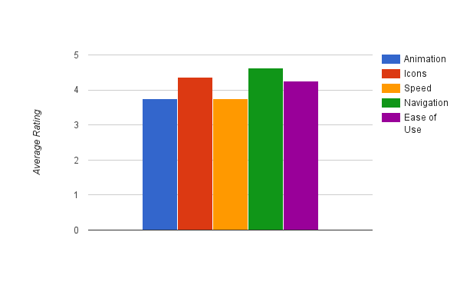**User Feedback**

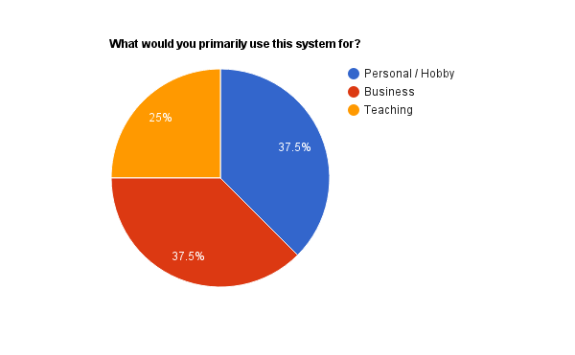

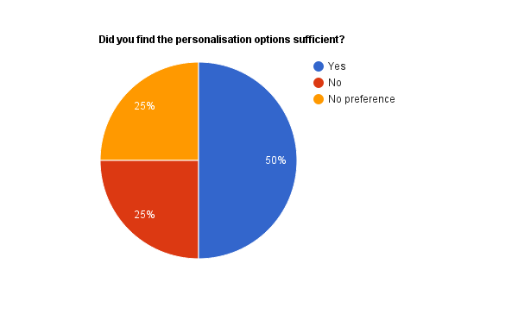

## C:\Users\Gian Paolo\Desktop\Capture.PNG

## Conclusions

From the gathered results, we identified a number of things to consider for future iterations of the system. The most noticeable and relevant of these are listed below.

* Graph interpretation

We noticed that some users were not sure what to do with the data they were receiving. In future, it could be possible to add certain indicators which provide the user with relevant contextual information.

* More customisation

Although not a major necessity, some users pointed out that they would like even more customisation, in terms of which graphs to display and being able to re-order plants and graphs.

* Additional helpful information

Initially, certain users struggled with plant box association. To alleviate this problem, we could create helpful videos and guides to which those users can be referred.

* Machine Learning

Although not represented within our usability test results, we as developers would like to incorporate machine learning at some point, so that users can follow pre-defined configurations to achieve the best possible results for their plants, using information gathered from other users.